**Introduction to Fundamental Analysis**

1.Fundamental Analysis (FA) is a approach to study a business.

2.When an investor wishes to invest in a business for the long term (say 3 – 5 years) it becomes extremely essential to understand the business

3.critical for an investor to separate the daily short term noise in the stock prices and concentrate on the underlying business performance.

4.Higher the CAGR faster is the wealth creation process.

5.Understanding the basic financial statements

6.Understand businesses with respect to the industry in which it operates(good business with healthy sales, great margins, innovative products, and an ethical management. )

7.Technical Analysis (TA) helps you garner quick short term returns.

**Mindset of an Investor**

Speculator Vs Trader Vs Investor

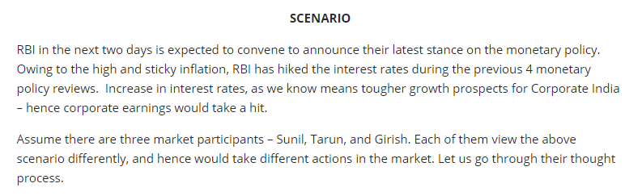

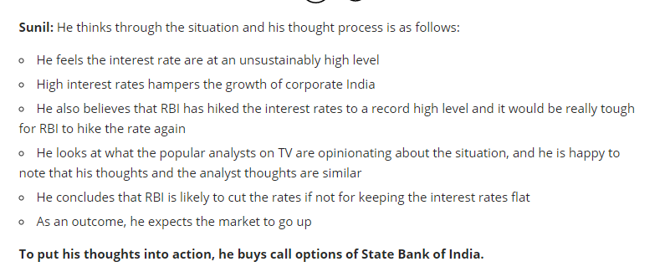

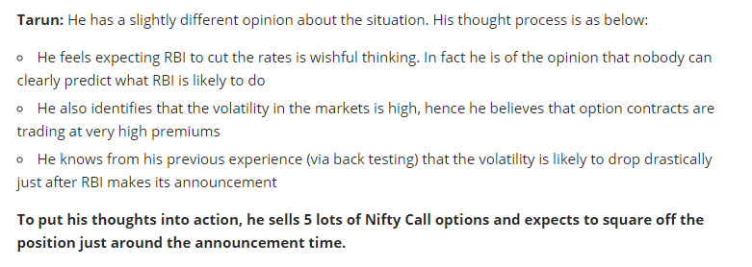

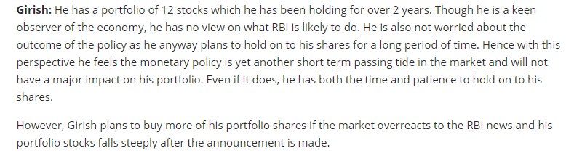

All the three men seem to have logic based on which they have taken a market action.

 In reality it is quite impossible to call a shot on what RBI (or for that matter any regulator) will do. These are complex matters and not straightforward to analyze.

Below are the some of the characteristics observed about the company.

